1.1 Experiment No. : 01
1.2 Experiment Name : Introduction to HTML Tags

1.3 Theory
The <html> tag is the root element of an HTML document, enclosing all other tags and marking the start and end of the HTML code. It tells browsers that the content uses HTML syntax.
The <head> element contains metadata and information vital for browsers and search engines but not visible on the page. It includes the <title> tag, which sets the page title shown on browser tabs, and <meta> tags that define character encoding (like UTF-8), page descriptions, viewport settings, and links to external CSS or scripts.
The <body> tag holds all the visible content on the webpage, including text, images, links, and interactive elements. It forms the main section of the HTML document.
Heading tags, from <h1> to <h6>, organize content hierarchically. <h1> indicates the most important heading, usually the page title, and <h6> the least. Using headings correctly helps accessibility and search engines understand the page structure.
Paragraphs are created with the <p> tag, grouping sentences into blocks to improve readability and spacing.
Inline formatting tags like <b>, <i>, and <u> style text as bold, italic, or underlined. The <strong> and <em> tags provide semantic emphasis beyond simple styling. The <span> tag is a generic inline container for applying styles or scripts without semantic meaning.
Lists organize information. Unordered lists <ul> show bullet points, ordered lists <ol> use numbers or letters, and list items are wrapped in <li> tags. Lists can be nested for complex hierarchies.
Hyperlinks use the <a> tag, with the href attribute specifying the destination URL. Attributes like target="_blank" open links in new tabs, and rel="nofollow" tells search engines not to follow the link.
Images are embedded using <img>, requiring src for the image URL and alt for alternative text, which aids screen readers and appears if the image doesn’t load. Optional attributes include width, height, and title.
Tables use <table> to contain rows <tr>, header cells <th>, and data cells <td>. Semantic tags like <thead>, <tbody>, and <tfoot> group table sections for better accessibility and styling.
Forms start with the <form> tag, containing input elements like <input> (text, checkbox, radio, etc.), <textarea> for multiline text, <select> with <option> for dropdowns, and <button> for clickable actions.
Semantic HTML5 tags clarify page structure: <header> defines introductory content, <footer> for closing information, <nav> for navigation links, <section> groups related content, <article> wraps standalone content, and <aside> marks tangential info like sidebars.
Multimedia tags <audio> and <video> embed media files, supporting attributes such as controls for playback controls, autoplay to start automatically, and loop to repeat. Nested <source> tags specify multiple formats for browser compatibility.
Attributes add extra info or control behavior. Common global attributes include id and class for styling and scripting, and style for inline CSS. Specific tags have custom attributes like href in anchors, src and alt in images, and type, name, and value in form inputs.
1.4 Problem Statement
Use basic HTML tags to create a simple web page
1.5 Source Code
<!DOCTYPE html>
<html lang="en">
<head>
<meta charset="Windows-1252" />
<meta name="viewport" content="width=device-width, initial-scale=1" />
<title>Document</title>
<style>
body {
background-color: antiquewhite;
display: flex;
gap: 2rem;
justify-content: center;
flex-direction: column;
font-family: Arial, Helvetica, sans-serif;
}
img {
align-self: center;
}
.red {
color: crimson;
}
.info {
background-color: white;
padding: 1em;
}
</style>
</head>
<body>
<h1>Information about BAUET</h1>
<p>
Welcome to <span class="red">BAUET.</span> This is located on
Kadirabad,Natore. Visit
<a href="https://bauet.ac.bd" rel="nofollow"> BAUET</a> website
</p>
<img alt="BAUET Building" height="200" src="./images/bauet.jpg" />
<div class="info">
<h2>Students</h2>
<p>There are <b>2000</b> students</p>
<p>Students are from different departments:</p>
<ol>
<li>CSE</li>
<li>EEE</li>
<li>CE</li>
<li>ME</li>
</ol>
</div>
<div class="info">
<h2>Teachers</h2>
<p>There are total <b>100</b> teachers.</p>
<p>The teachers are :</p>
<ul>
<li>Professor</li>
<li>Associate Professor</li>
<li>Assistant Professor</li>
<li>Lecturer</li>
</ul>
</div>
<div class="info">
<h2>Departments</h2>
<p>There total <b>13</b> Departments.</p>
<h3>Faculty of Electrical and Computer Engineering (FECE)</h3>
<ul>
<li>Department of Computer Science and Engineering (CSE)</li>
<li>
Department of Electrical and Electronic Engineering (EEE)
</li>
<li>
Department of Information and Communication Engineering
(ICE)
</li>
</ul>

<h3>Faculty of Civil and Environmental Engineering (FCEE)</h3>
<ul>
<li>Department of Civil Engineering (CE)</li>
</ul>

<h3>Faculty of Mechanical and Production Engineering (FMPE)</h3>
<ul>
<li>Department of Mechanical Engineering (ME)</li>
<li>
Department of Industrial and Production Engineering (IPE)
</li>
</ul>

<h3>Faculty of Business Studies (FBS)</h3>
<ul>
<li>Department of Business Administration (BBA)</li>
</ul>

<h3>Faculty of Science and Humanities (FSH)</h3>
<ul>
<li>Department of English</li>
<li>Department of Mathematics</li>
</ul>
</div>
</body>
</html>

1.6 Output
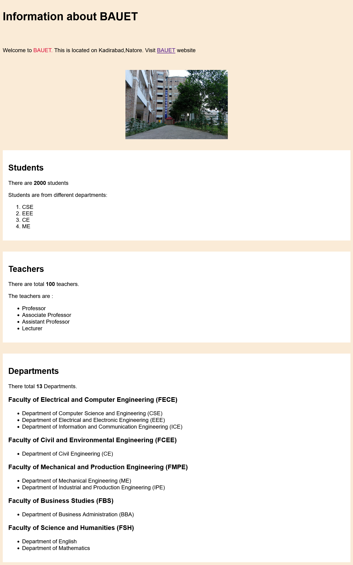

1.7 Discussion
In this experiment, a complete HTML web page titled "Information about BAUET" was created using various essential HTML tags and CSS styling. Structural tags such as <html>, <head>, and <body> were used to organize the page. Content was formatted using headings (<h1>, <h2>, <h3>), paragraphs (<p>), bold text (<b>), and spans (<span>) for inline styling. Lists—both ordered (<ol>) and unordered (<ul>)—were employed to present grouped information clearly.
An image was inserted with appropriate alt text, and a hyperlink to the official BAUET website was provided using the <a> tag. CSS styles were applied internally within the <style> tag. Flexbox layout was utilized to center the content and add spacing, while custom classes like .info and .red were used to highlight and group specific sections.
Through this practice, a better understanding of how HTML tags and CSS work together to build structured and visually appealing web pages was gained.

